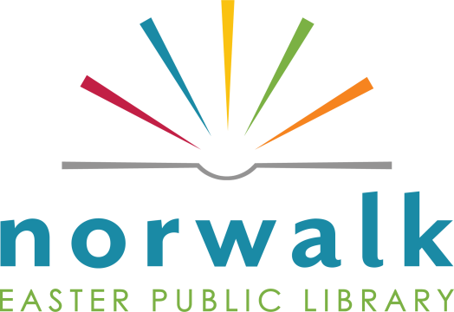

FOR IMMEDIATE RELEASE: Contact: Library Director Jean Bosch,
jbosch@norwalk.iowa.gov

Norwalk Library Celebrates National Library Week

During National Library Week, April 4-10, 2021, Norwalk Easter Public Library encourages all community members to visit the library or website to explore and access the services, collections, and programs.

This celebration is a time to highlight the essential role libraries, librarians, and library workers play in transforming lives and strengthening communities. The theme for this year’s National Library Week is “Welcome to Your Library,” which promotes the idea that libraries extend far beyond the four walls of a building and that everyone is welcome to use their services. Whether people visit virtually or in person, libraries are accessible and inclusive places that foster a sense of belonging and community through learning, discovery and exploration.

“Norwalk Easter Public Library is so much more than a storehouse of books. We offer numerous learning and recreational opportunities such as movies, ebooks, online homework help, Launchpads, kits, a seed library, and take-and-make activities, just to name a few great things,” said Library Director Jean Bosch.

To celebrate this special week, the Norwalk Fareway Store is offering “Round Up for Reading” where shoppers can add to their Fareway register receipt total at check out with funds raised to support library programs and activities. There is also a special proclamation from Norwalk Mayor Tom Phillips that will be issued at the April 1 City Council meeting.

National Library Week is an annual celebration sponsored by the American Library Association highlighting the valuable role libraries, librarians, and library workers play in transforming lives and strengthening our communities.

More information can be found browsing www.norwalklibrary.org , emailing library@norwalklibrary.iowa.gov, or by calling the staff at 515-981-0217.

###

